* **R-2301 WEST – CACTUS WEST AIRSPACE – YODAVILLE URBAN TARGET COMPLEX (UTC)**\*\***CLOSED** 12-24 September, 2024 (MGRS 11S QR5085292094 or N 32°26.26558', W114°19.91296')** There will be personnel and equipment within the UTC performing operational range clearance and other construction activity.  **NO ORDNANCE OR LASING AUTHORIZED**.  For additional information, contact Yuma Range Scheduling POC Mr. Alan Veasey (928) 269-5575/2214 or Mr. Jon Gordon 928-269-6488.

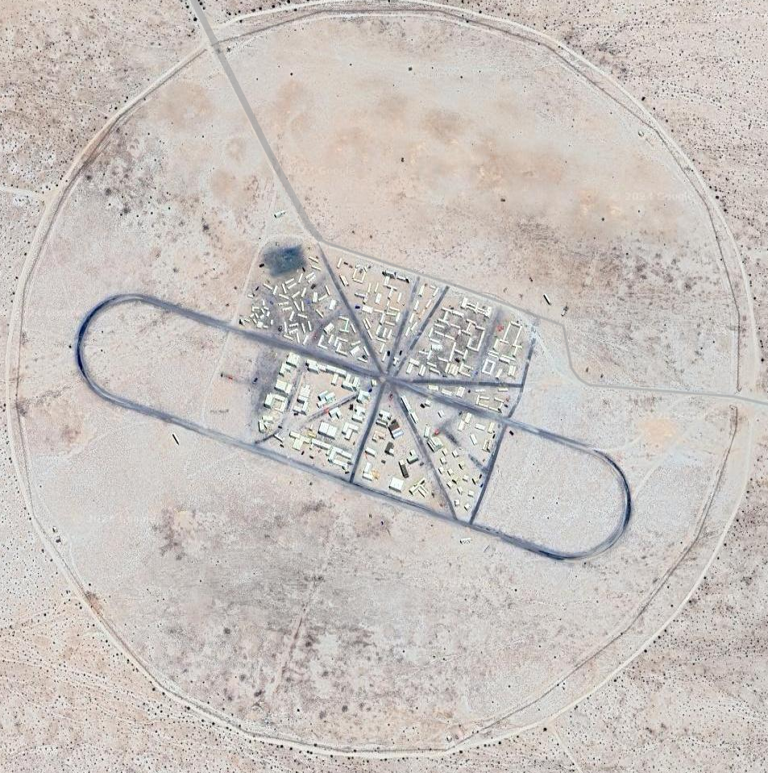

* **R-2301 WEST – CACTUS WEST – CACTUS WEST BULL’S-EYE -**The Cactus West Bull’s-eye Target lighting will be down until further notice.  For more information please contact WISS Scoring at 928-269-1669 or 1668.
* **Within R-2301W** - During the dates 15 March to 15 July in accordance with U.S. Fish and Wildlife measures to protect the Sonoran pronghorn habitat, non-WTI aircraft flights shall remain west of the 113°53’W longitude line, or on designated transit routes, or above 1,500 ft.  AGL (when flying east of this line).  Refer to, STAO 3710.6, Range Regulations, Section 4004.5 TACTS LOW, Para. 5 Special Instructions, b.
* **R-2301 West – Cactus West/ UTC Yodaville** -  **30 MM MUNITIONS NOT AUTHORIZED IN THE TARGET AREAS**.  For additional information, contact Mr. Alan Veasey DSN 269-2214/5575, or Leg Iron 928-269-7080.​​
* **Bullseye Scoring** available by keying up 311.85.
* 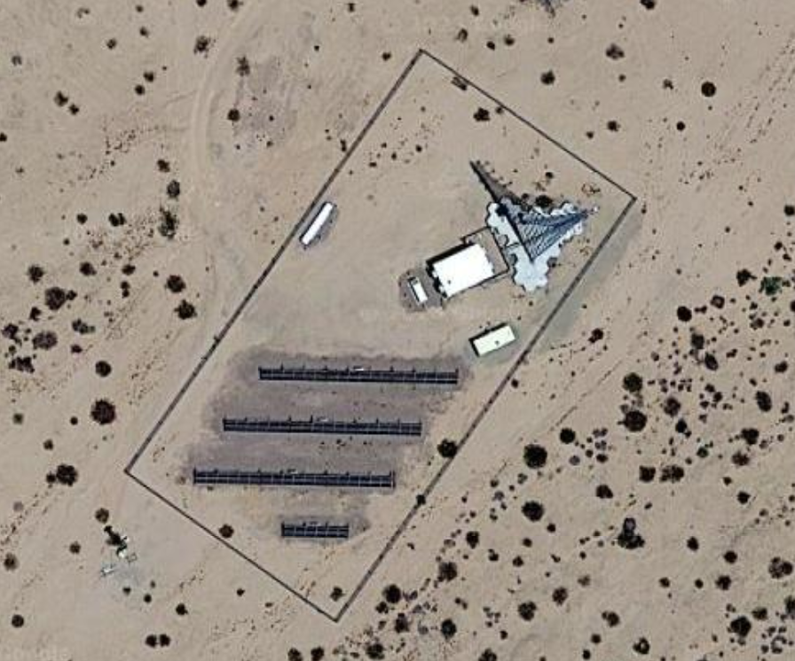**R-2301 West – TACTS Lo** - There is a is a Tower Obstruction at 32.490491, -113.882442 or 12S TA 29149 98467 with an inoperable obstruction light at 199’ AGL. Please be advised to avoid this location, especially during night time. No confirmed operational timeframe is available at this time. Please continue to check this website for updates.